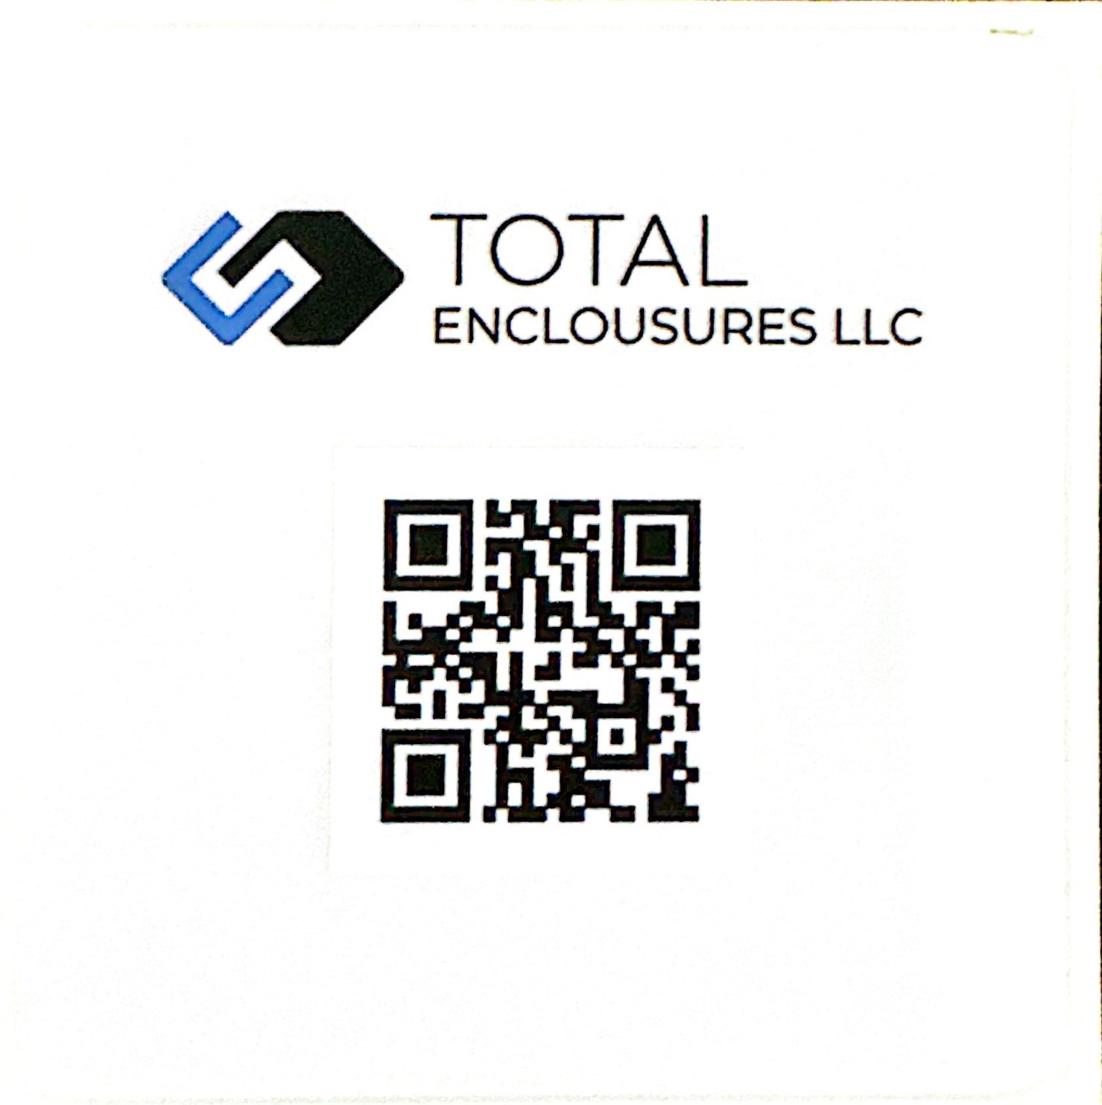
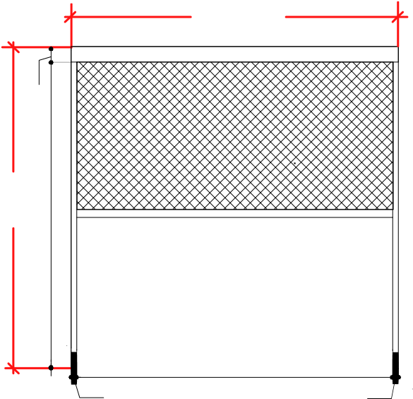
A_

Project Name
PI Number | TE0103- 01- -A1____
Costumer :
Drawing Date :

B_

Requirements:
1.Frame Material: 6063-T5 Aluminum Alloy
2.Fabric Material: 75% PVC+25% PET
3.Cover Box Size: x x2.0mm
4.SideRailSize: X X1.3mm
5.Motor Voltage: 110V 50N
6.Frame Color:
7.Fabric Color:
8.Fabric Light Transmittance: | 0 | 1 | 5 |
9.System: | Remote Control | External WS |
10.Measurements:
C_

D_

Confirm By Costumer:

